PYTHON MODULE END ASSIGNMENT

SURVEY FEEDBACK ANALYZER

TOOLS: Python / VS Code
PROJECT TITLE: Python Data Analysis – Survey Feedback Analyzer
PROJECT OBJECTIVE: Working with Dictionaries and Lists, collecting and cleaning textual feedback, applying Loops (while, for), Control Statements (break, continue, else), String Operations, and User-Defined Functions to analyze survey feedback and extract meaningful insights.
DATE OF SUBMISSION: 22/10/2026 – 3:30 PM

SURVEY FEEDBACK ANALYZER:
CREATE A NEW PYTHON FILE "PYTHON SURVEY FEEDBACK ANALYZER.PY" IN VS CODE.
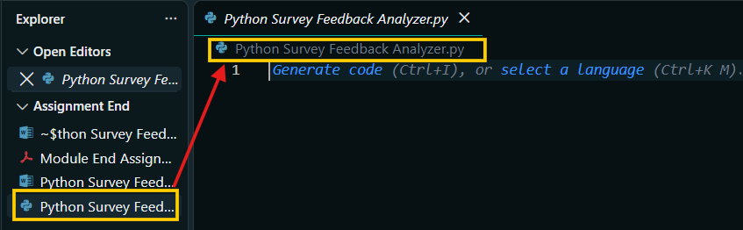
1) PRELOADED FEEDBACK DATA:
PRELOADED DATA STORED IN THE "FEEDBACK_DATA" DICTIONARY (S_NO, NAME, FEEDBACK AND RATING).
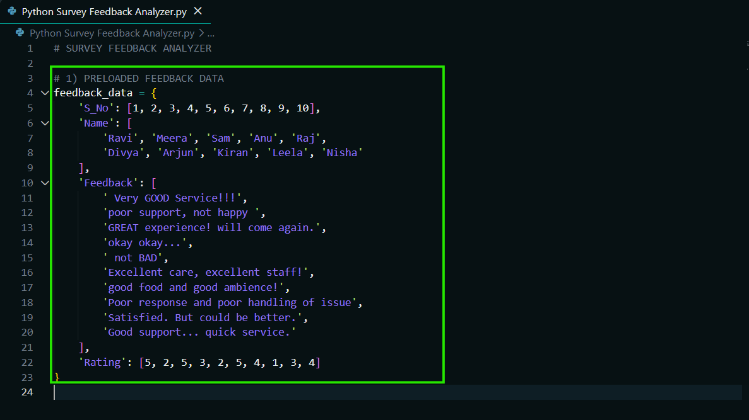
2) ADDING MORE FEEDBACKS:
2.1) ASKING HOW MANY FEEDBACKS TO ADD.
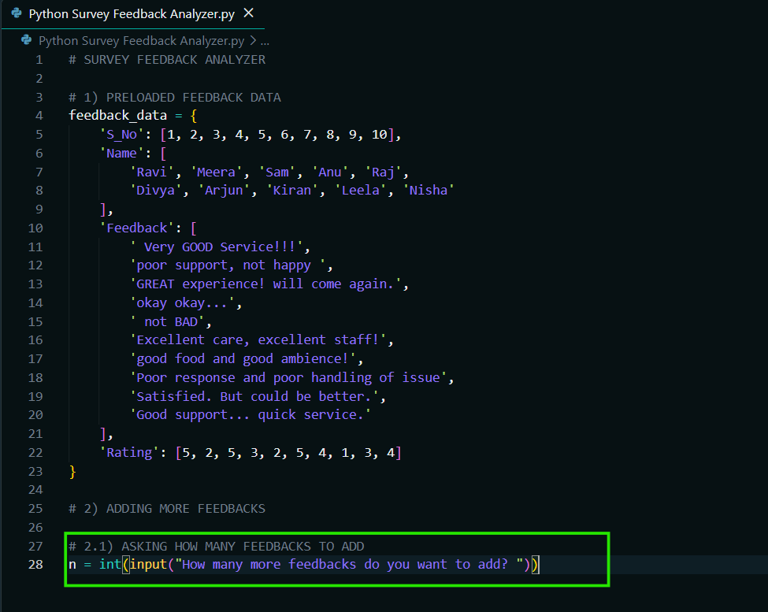
2.2) COLLECTING NEW FEEDBACKS.
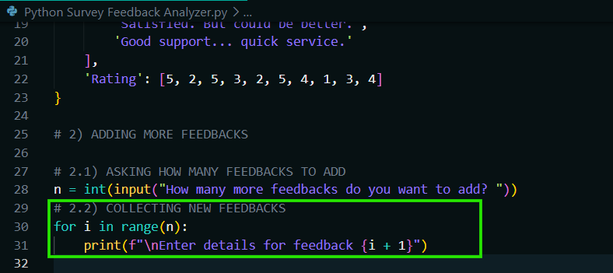
2.3) COLLECTING NAME, FEEDBACK AND RATING.
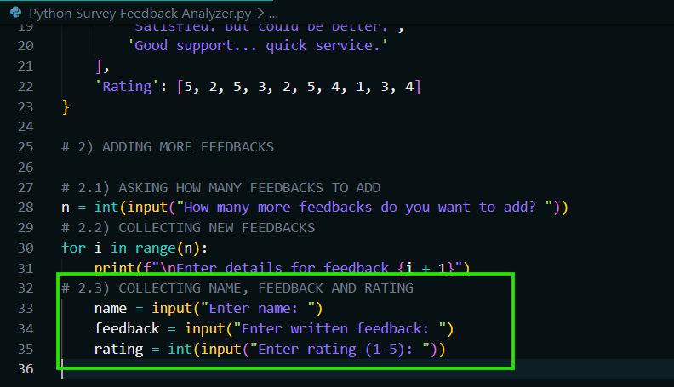
2.4) VALIDATING RATING 1 TO 5 USING "WHILE" LOOP.
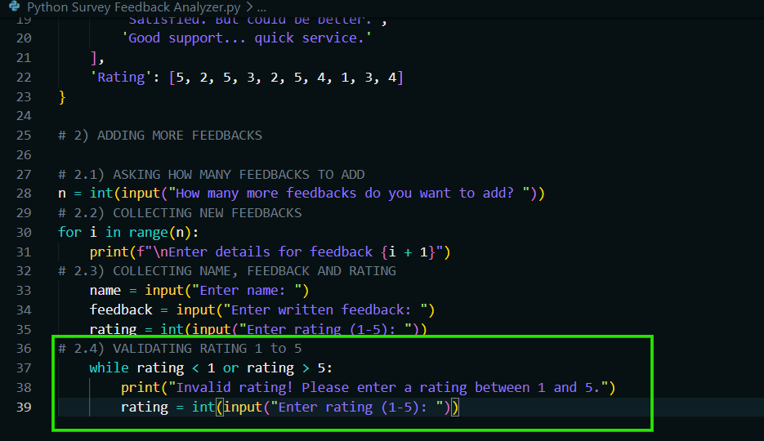
2.5) APPENDING DATA FOR NEW FEEDBACK TO THE "FEEDBACK_DATA" DICTIONARY.
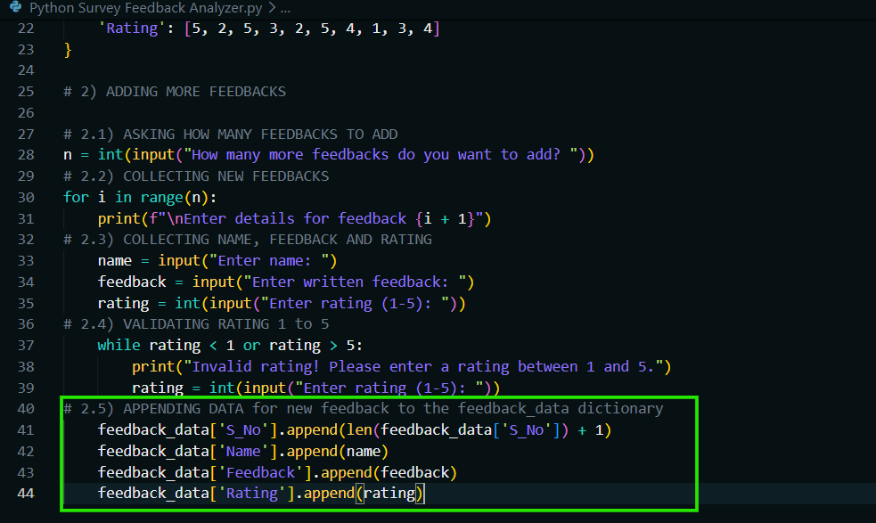

3) TEXT CLEANING:
3.1) DEFINING "PUNCTUATION" TO REMOVE.
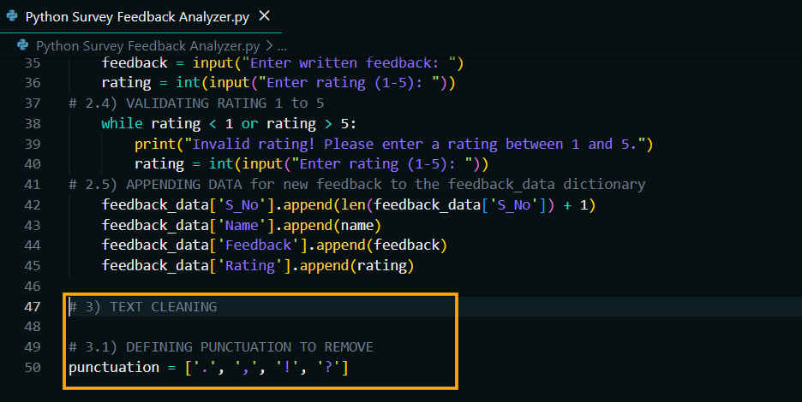
3.2) LOOPING THROUGH EACH FEEDBACK AND CLEANING IT.
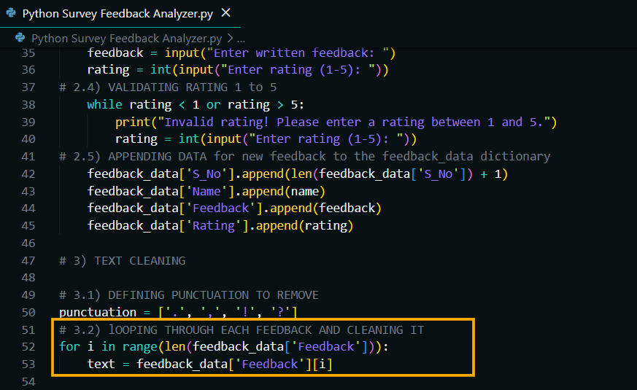
3.3) REMOVING PUNCTUATION FROM THE FEEDBACK TEXT.
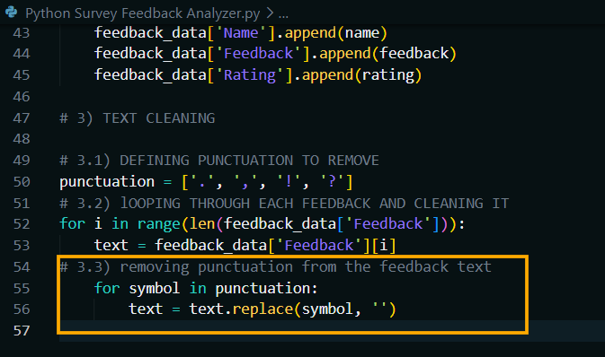
3.4) CONVERTING TO LOWERCASE USING "LOWER()".
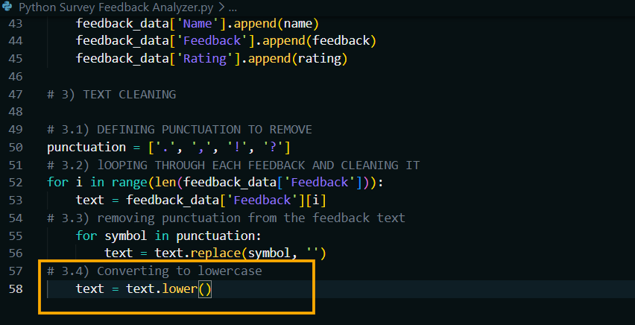
3.5) REMOVING EXTRA SPACES AND JOINING WORDS USING "SPLIT()" AND "JOIN()".
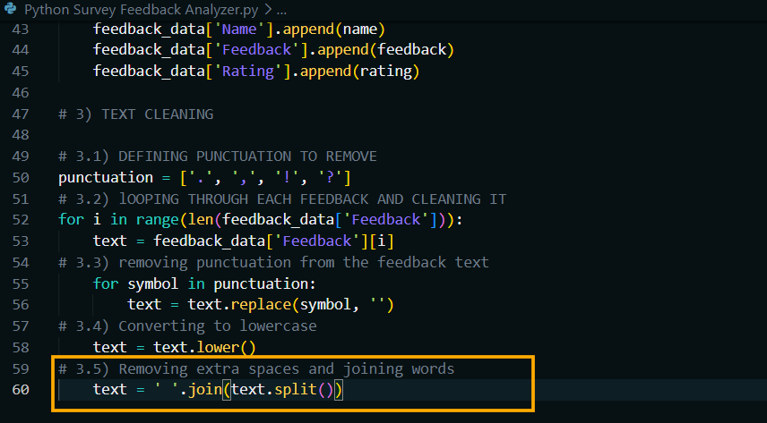
3.6) UPDATING CLEANED FEEDBACK.
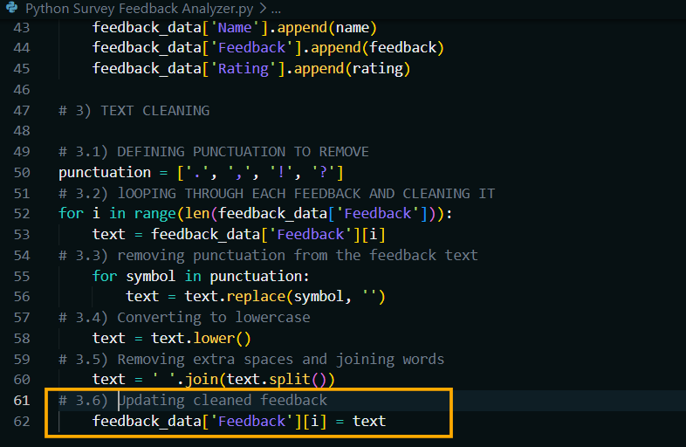
4) WORD COUNT INSIGHTS:
4.1) DEFINING THE FUNCTION "COUNT_WORD_IN_FEEDBACKS".
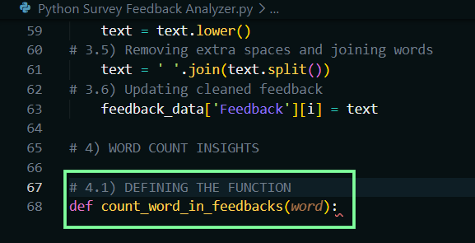
4.2) INITIALIZING THE COUNT VARIABLE.
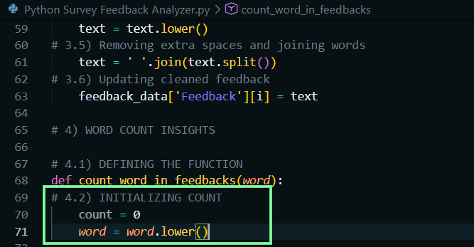
4.3) COUNTING OCCURRENCES OF THE WORD IN ALL FEEDBACKS.
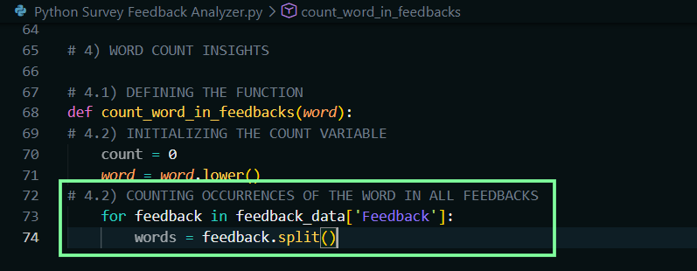
4.4) CHECKING IF THE WORD IS PRESENT IN THE FEEDBACK.
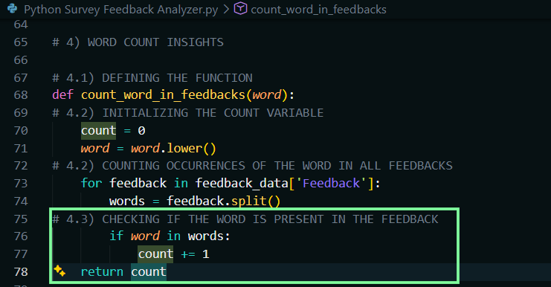

4.5) DISPLAYING THE INSIGHTS: GOOD, POOR, EXCELLENT.
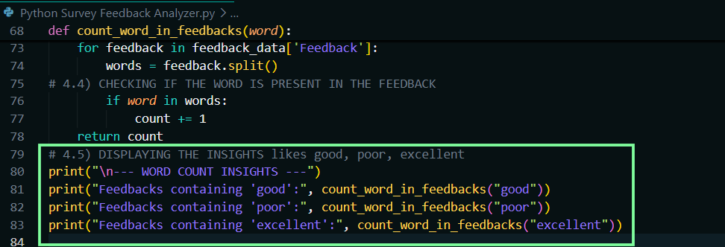
5) FINAL SURVEY FEEDBACK DATA AFTER CLEANING AND INSIGHTS:
5.1) DISPLAYING CLEANED FEEDBACK DATA.
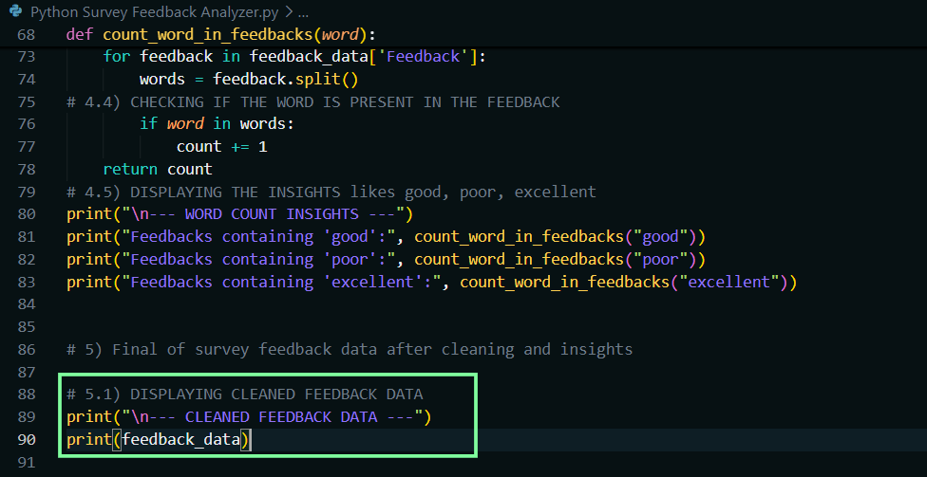
5.2) CALCULATING AVERAGE RATING.
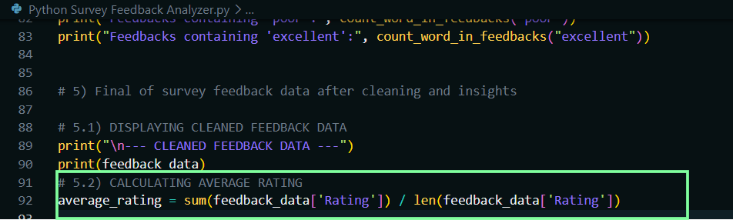
5.3) DISPLAYING AVERAGE RATING.
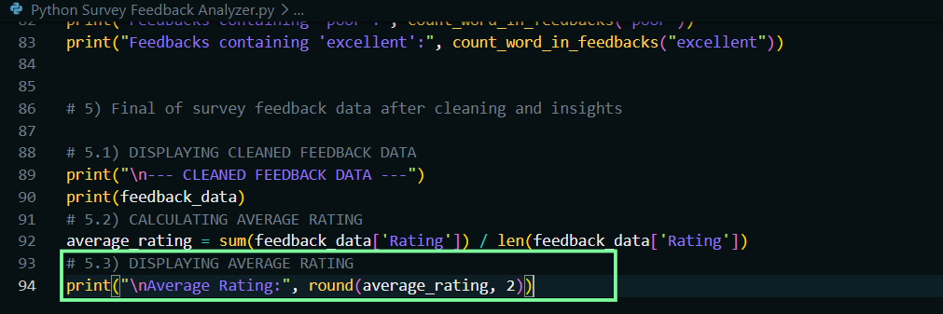
5.4) FINDING THE FEEDBACK WITH THE LONGEST WORD COUNT USING "MAX()".
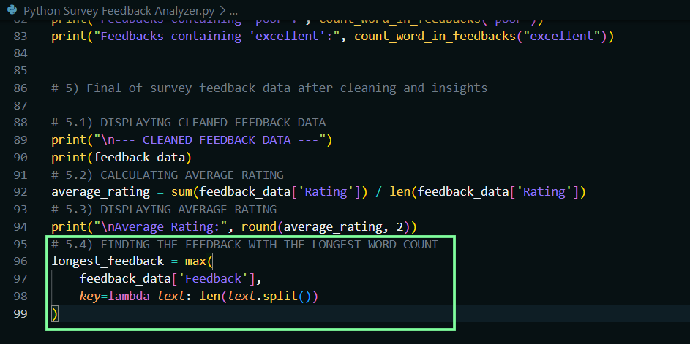
5.5) DISPLAYING THE LONGEST FEEDBACK AND ITS WORD COUNT.
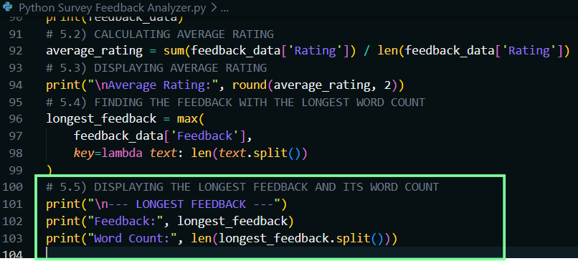
5.6) FINDING UNIQUE WORDS IN ALL FEEDBACKS USING A "SET".
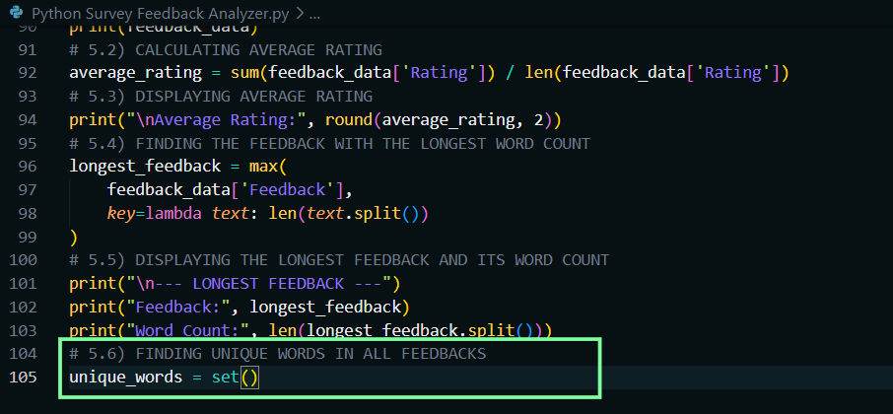
5.7) LOOPING THROUGH EACH FEEDBACK TO EXTRACT UNIQUE WORDS.
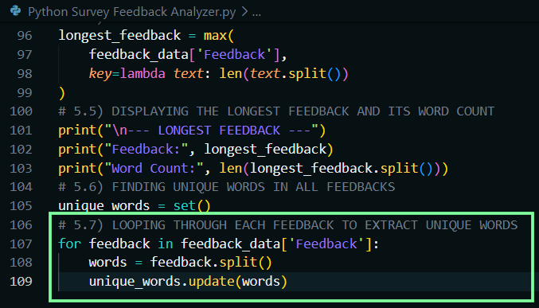
5.8) DISPLAYING UNIQUE WORDS AND THEIR COUNT.
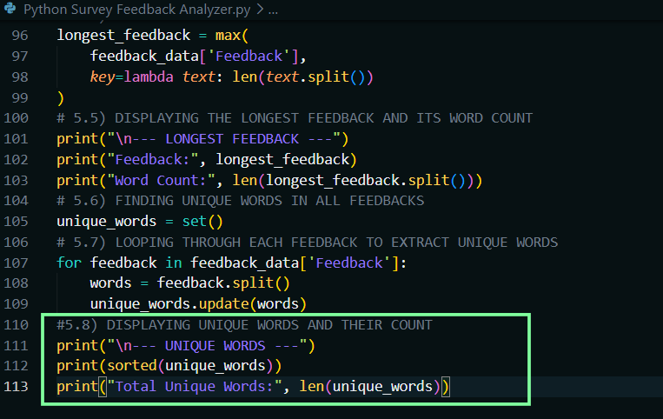
5.9) SORTING FEEDBACK DATA BY RATING IN DESCENDING ORDER USING "ZIP()" AND "SORTED()".
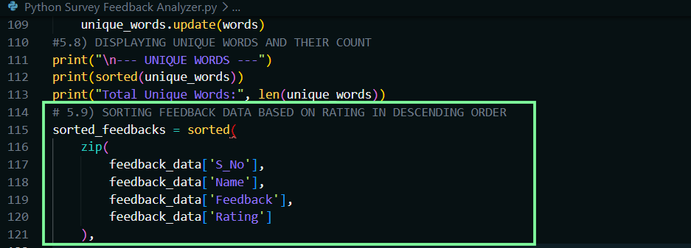
5.10) SORTING BASED ON RATING IN DESCENDING ORDER USING "KEY" AND "REVERSE=TRUE".
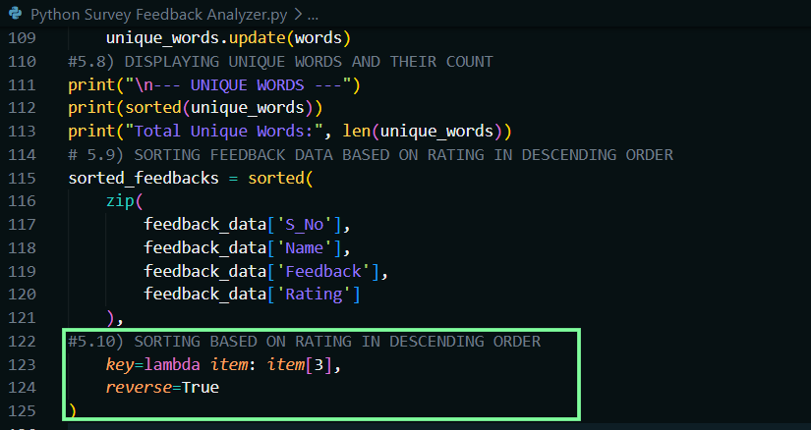
5.11) DISPLAYING SORTED FEEDBACKS BASED ON RATING.
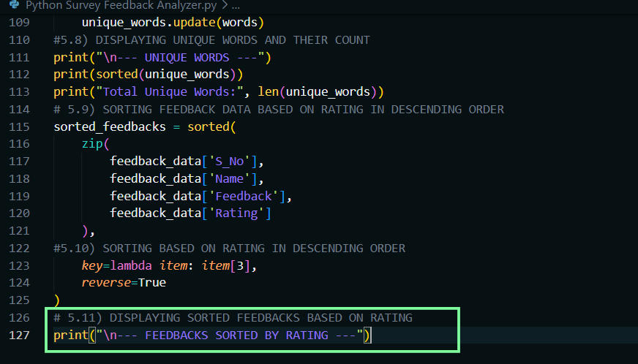
5.12) LOOPING THROUGH SORTED FEEDBACKS AND PRINTING DETAILS.
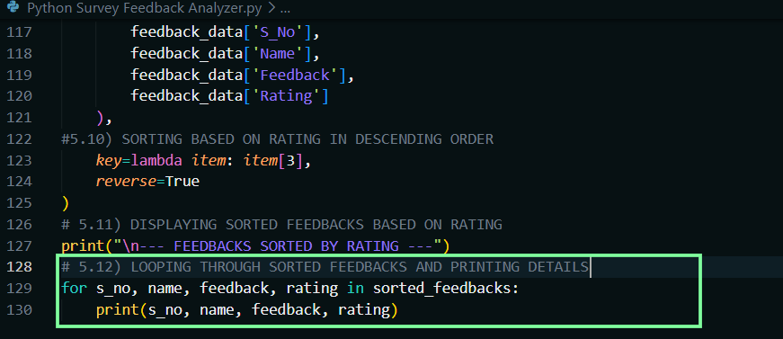

SOURCE CODE – SURVEY FEEDBACK ANALYZER:
# SURVEY FEEDBACK ANALYZER

# 1) PRELOADED FEEDBACK DATA
feedback_data = {
'S_No': [1, 2, 3, 4, 5, 6, 7, 8, 9, 10],
'Name': [
'Ravi', 'Meera', 'Sam', 'Anu', 'Raj',
'Divya', 'Arjun', 'Kiran', 'Leela', 'Nisha'
],
'Feedback': [
' Very GOOD Service!!!',
'poor support, not happy ',
'GREAT experience! will come again.',
'okay okay...',
' not BAD',
'Excellent care, excellent staff!',
'good food and good ambience!',
'Poor response and poor handling of issue',
'Satisfied. But could be better.',
'Good support... quick service.'
],
'Rating': [5, 2, 5, 3, 2, 5, 4, 1, 3, 4]
}

# 2) ADDING MORE FEEDBACKS

# 2.1) ASKING HOW MANY FEEDBACKS TO ADD
n = int(input("How many more feedbacks do you want to add? "))
# 2.2) COLLECTING NEW FEEDBACKS
for i in range(n):
print(f"\nEnter details for feedback {i + 1}")
# 2.3) COLLECTING NAME, FEEDBACK AND RATING
name = input("Enter name: ")
feedback = input("Enter written feedback: ")
rating = int(input("Enter rating (1-5): "))
# 2.4) VALIDATING RATING 1 TO 5
while rating < 1 or rating > 5:
print("Invalid rating! Please enter a rating between 1 and 5.")
rating = int(input("Enter rating (1-5): "))
# 2.5) APPENDING DATA FOR NEW FEEDBACK TO THE DICTIONARY
feedback_data['S_No'].append(len(feedback_data['S_No']) + 1)
feedback_data['Name'].append(name)
feedback_data['Feedback'].append(feedback)
feedback_data['Rating'].append(rating)

# 3) TEXT CLEANING

# 3.1) DEFINING PUNCTUATION TO REMOVE
punctuation = ['.', ',', '!', '?']
# 3.2) LOOPING THROUGH EACH FEEDBACK AND CLEANING IT
for i in range(len(feedback_data['Feedback'])):
text = feedback_data['Feedback'][i]
# 3.3) REMOVING PUNCTUATION FROM THE FEEDBACK TEXT
for symbol in punctuation:
text = text.replace(symbol, '')
# 3.4) CONVERTING TO LOWERCASE
text = text.lower()
# 3.5) REMOVING EXTRA SPACES AND JOINING WORDS
text = ' '.join(text.split())
# 3.6) UPDATING CLEANED FEEDBACK
feedback_data['Feedback'][i] = text

# 4) WORD COUNT INSIGHTS

# 4.1) DEFINING THE FUNCTION
def count_word_in_feedbacks(word):
# 4.2) INITIALIZING THE COUNT VARIABLE
count = 0
word = word.lower()
# 4.3) COUNTING OCCURRENCES OF THE WORD IN ALL FEEDBACKS
for feedback in feedback_data['Feedback']:
words = feedback.split()
# 4.4) CHECKING IF THE WORD IS PRESENT IN THE FEEDBACK
if word in words:
count += 1

return count
# 4.5) DISPLAYING THE INSIGHTS LIKE GOOD, POOR, EXCELLENT
print("\n--- WORD COUNT INSIGHTS ---")
print("Feedbacks containing 'good':", count_word_in_feedbacks("good"))
print("Feedbacks containing 'poor':", count_word_in_feedbacks("poor"))
print("Feedbacks containing 'excellent':", count_word_in_feedbacks("excellent"))

# 5) FINAL SURVEY FEEDBACK DATA AFTER CLEANING AND INSIGHTS

# 5.1) DISPLAYING CLEANED FEEDBACK DATA
print("\n--- CLEANED FEEDBACK DATA ---")
print(feedback_data)
# 5.2) CALCULATING AVERAGE RATING
average_rating = sum(feedback_data['Rating']) / len(feedback_data['Rating'])
# 5.3) DISPLAYING AVERAGE RATING
print("\nAverage Rating:", round(average_rating, 2))
# 5.4) FINDING THE FEEDBACK WITH THE LONGEST WORD COUNT
longest_feedback = max(
feedback_data['Feedback'],
key=lambda text: len(text.split())
)
# 5.5) DISPLAYING THE LONGEST FEEDBACK AND ITS WORD COUNT
print("\n--- LONGEST FEEDBACK ---")
print("Feedback:", longest_feedback)
print("Word Count:", len(longest_feedback.split()))
# 5.6) FINDING UNIQUE WORDS IN ALL FEEDBACKS
unique_words = set()
# 5.7) LOOPING THROUGH EACH FEEDBACK TO EXTRACT UNIQUE WORDS
for feedback in feedback_data['Feedback']:
words = feedback.split()
unique_words.update(words)
# 5.8) DISPLAYING UNIQUE WORDS AND THEIR COUNT
print("\n--- UNIQUE WORDS ---")
print(sorted(unique_words))
print("Total Unique Words:", len(unique_words))
# 5.9) SORTING FEEDBACK DATA BASED ON RATING IN DESCENDING ORDER
sorted_feedbacks = sorted(
zip(
feedback_data['S_No'],
feedback_data['Name'],
feedback_data['Feedback'],
feedback_data['Rating']
),
# 5.10) SORTING BASED ON RATING IN DESCENDING ORDER
key=lambda item: item[3],
reverse=True
)
# 5.11) DISPLAYING SORTED FEEDBACKS BASED ON RATING
print("\n--- FEEDBACKS SORTED BY RATING ---")
# 5.12) LOOPING THROUGH SORTED FEEDBACKS AND PRINTING DETAILS
for s_no, name, feedback, rating in sorted_feedbacks:
print(s_no, name, feedback, rating)

OUTPUT – SURVEY FEEDBACK ANALYZER:
PS D:\ENTRI ELEVATE DOCUMENTS\PYTHON PROGRAM\Assignment\Assignment End> & C:\Users\Venkadesh\AppData\Local\Programs\Python\Python314\python.exe "d:/ENTRI ELEVATE DOCUMENTS/PYTHON PROGRAM/Assignment/Assignment End/Python Survey Feedback Analyzer.py"
How many more feedbacks do you want to add? 1

Enter details for feedback 1
Enter name: Ravi
Enter written feedback: good
Enter rating (1-5): 4

--- WORD COUNT INSIGHTS ---
Feedbacks containing 'good': 4
Feedbacks containing 'poor': 2
Feedbacks containing 'excellent': 1

--- CLEANED FEEDBACK DATA ---
{'S_No': [1, 2, 3, 4, 5, 6, 7, 8, 9, 10, 11], 'Name': ['Ravi', 'Meera', 'Sam', 'Anu', 'Raj', 'Divya', 'Arjun', 'Kiran', 'Leela', 'Nisha', 'Ravi'], 'Feedback': ['very good service', 'poor support not happy', 'great experience will come again', 'okay okay', 'not bad', 'excellent care excellent staff', 'good food and good ambience', 'poor response and poor handling of issue', 'satisfied but could be better', 'good support quick service', 'good'], 'Rating': [5, 2, 5, 3, 2, 5, 4, 1, 3, 4, 4]}

Average Rating: 3.45

--- LONGEST FEEDBACK ---
Feedback: poor response and poor handling of issue
Word Count: 7

--- UNIQUE WORDS ---
['again', 'ambience', 'and', 'bad', 'be', 'better', 'but', 'care', 'come', 'could', 'excellent', 'experience', 'food', 'good', 'great', 'handling', 'happy', 'issue', 'not', 'of', 'okay', 'poor', 'quick', 'response', 'satisfied', 'service', 'staff', 'support', 'very', 'will']
Total Unique Words: 30

--- FEEDBACKS SORTED BY RATING ---
1 Ravi very good service 5
3 Sam great experience will come again 5
6 Divya excellent care excellent staff 5
7 Arjun good food and good ambience 4
10 Nisha good support quick service 4
11 Ravi good 4
4 Anu okay okay 3
9 Leela satisfied but could be better 3
2 Meera poor support not happy 2
5 Raj not bad 2
8 Kiran poor response and poor handling of issue 1
PS D:\ENTRI ELEVATE DOCUMENTS\PYTHON PROGRAM\Assignment\Assignment End>

